Smart Edge-Based Driver Drowsiness Detection in Mobile Crowdsourcing

ABSTRACT:

According to current data, sleepy drivers are responsible for an estimated 15.5% of fatal traffic accidents, which presents a serious threat to public safety. This research presents a unique solution to Driver Drowsiness Detection utilising Convolutional Neural Networks (CNN) combined with Flask for image/live input in order to handle this problem and take use of the extensive use of mobile devices. With this two-step technique, mobile devices in the car record and evaluate the driver's present state while protecting their privacy. As a decision-maker, the smart edge verifies drowsiness whether the data from the mobile client matches the real-time input that was observed. The suggested framework includes a data fusion technique and is centred on the distributed edge architecture, which guarantees effective administration of the area of interest. This method uses flask manual input or real-time input of the car environment and the CNN model to identify driver fatigue locally based on facial expressions. With an average accuracy of 97.7%, the framework's sleepiness detection performance is remarkable.

TABLE OF CONTENTS
CHAPTER NO. | TITLE | PAGE NO.
 | ABSTRACT  LIST OF FIGURES  LIST OF SYMBOLS | i  v  vii
1. | CHAPTER 1 : INTRODUCTION  - GENERAL  - SCOPE OF THE PROJECT  - OBJECTIVE  1.4 EXISTING SYSTEM  1.4.1 EXISTINGSYSTEM DISADVANTAGES  1.5 LITERATURE SURVEY  1.6 PROPOSED SYSTEM  1.6.1 PROPOSED SYSTEM ADVANTAGES
2. | CHAPTER 2 :PROJECT DESCRIPTION  2.1 GENERAL  2.2 METHODOLOGIES  2.2.1 MODULES NAME  2.2.2 MODULES EXPLANATION  2.3 TECHNIQUE OR ALGORITHM
3. | CHAPTER 3 : REQUIREMENTS  3.1 General  3.2 Hardware REQUIREMENTS  3.3 Software REQUIREMENTS
4. | CHAPTER 4 :SYSTEM DESIGN  4.1 general  4.2 uml diagrams  4.2.1 USE CASE DIAGRAM  4.2.2 CLASS DIAGRAM  4.2.3 OBJECT DIAGRAM  4.2.4 STATE DIAGRAM  4.2.5 activity diagram  4.2.6 SEQUENCE DIAGRAM  4.2.7 COLLABORATION DIAGRAM  4.2.8 COMPONENT DIAGRAM  4.2.9 DATA FLOW DIAGRAM  4.2.10 DEPLOYMENT DIAGRAM  4.2.11 SYSTEM ARCHITECTURE
5. | CHAPTER 5 : DEVELOPMENT TOOLS  5.1 general  5.2 History of Python  5.3 Importance of Python  5.4 Features of Python  5.5 Libraries used in python
6. | CHAPTER 6 :IMPLEMENTATION  6.1 GENERAL  6.2 IMPLEMENTATION

7. | CHAPTER 7 :SNAPSHOTS  7.1 GENERAL  7.2 VARIOUS SNAPSHOTS
8. | CHAPTER 8 :SOFTWARE TESTING  8.1 GENERAL  8.2 DEVELOPING METHODOLOGIES  8.3 TYPES OF TESTING
9. | CHAPTER 9 :  FUTURE ENHANCEMENT  9.1 FUTURE ENHANCEMENTS
10 | CHAPTER 10 :  10.1CONCLUSION  10.2 REFERENCES

LIST OF FIGURES

FIGURE NO | NAME OF THE FIGURE | PAGE NO.
4.1 | Use case Diagram
4.2 | Class diagram
4.3 | Object diagram
4.4 | State Diagram
4.5 | Activity Diagram
4.6 | Sequence diagram
4.7 | Collaboration diagram
4.8 | Component Diagram
4.9 | Data flow diagram
4.10 | Deployment Diagram
4.11 | Architecture Diagram

LIST OF SYSMBOLS

S.NO | NOTATION  NAME | NOTATION | DESCRIPTION
1. | Class | Class Name  -attribute  -attribute  +operation  +operation  +operation  + public  -private  # protected | Represents a collection of similar entities grouped together.
2. | Association | name  Class B  Class A  Class A  Class B | Associations represents static relationships between classes. Roles represents the way the two classes see each other.
3. | Actor | Class A  Class A  Class B  Class B | It aggregates several classes into a single classes.
4. | Aggregation | Class A  Class A  Class B  Class B | Interaction between the system and external environment

5. | Relation  (uses) | uses | Used for additional process communication.
6. | Relation  (extends) | extends | Extends relationship is used when one use case is similar to another use case but does a bit more.
7. | Communication |  | Communication between various use cases.
8. | State | State | State of the processes.
9. | Initial State |  | Initial state of the object
10. | Final state |  | Final state of the object
11. | Control flow |  | Represents various control flow between the states.
12. | Decision box |  | Represents decision making process from a constraint
13. | Use case | Uses case | Interact ion between the system and external environment.
14. | Component |  | Represents physical modules which are a collection of components.
15. | Node |  | Represents physical modules which are a collection of components.
16. | Data Process/State |  | A circle in DFD represents a state or process which has been triggered due to some event or action.
17. | External entity |  | Represents external entities such as keyboard, sensors, etc.
18. | Transition |  | Represents communication that occurs between processes.
19. | Object Lifeline |  | Represents the vertical dimensions that the object communications.
20. | Message | Message | Represents the message exchanged.

CHAPTER-1
INTRODUCTION
1.1 INRODUCTION:
As Drowsy driving results in about 328,000 crashes yearly. It contributes to approximately 15.5% and 13.1% of fatal accidents causing deaths and injuries. It happens when the person is driving with extreme drowsiness, making him not alert enough to respond to traffic events. An accurate drowsiness detection system that runs in real-time could help reduce drowsy driving accidents. However, existing solutions are limited by the drawbacks of the methodologies they use.
In the literature, mainly three methodologies are used to detect driver status, namely vehicle behavior monitoring methods, physiological-based methodologies, and computer vision approaches. These methods rely on different features to build detection systems. Vehicle behavior methods utilize trends such as steering activity and vehicle position variability relative to road features. However, these methods suffer from the unpredictability of the driving environment and the differences in driving habits between drivers, making them less reliable than the other approaches. Physiological-based methodologies depend on electroencephalogram (EEG) and heart rate variability measures collected via wearable devices. However, EEG devices are susceptible to vibrations generated by motion and engine. Therefore they fail to perform well in real driving conditions. Finally, computer vision approaches rely on eye movement, yawning, and head orientation extracted from video streams or images. They are the most user-friendly and accurate approaches as they do not require wearing any measuring devices and are relatively independent of the external environment. Nevertheless, the performance of computer vision methods is affected by varying light conditions. They also tend to be computationally expensive and are not efficient to be implemented on embedded systems.
.

1.2 SCOPE OF THE PROJECT

In order to solve the serious problem of sleepy driving, this research suggests a novel Driver Drowsiness Detection system. The project's scope includes utilising Flask and Convolutional Neural Networks (CNN) for real-time image input, mainly by taking advantage of the widespread use of mobile devices using our website. With a focus on privacy, the system uses mobile devices in the car to monitor and record the driver's condition. The framework, which makes use of a distributed edge architecture and data fusion technique, guarantees efficient management of the allocated area and demonstrates its adaptability by combining live and manual inputs for thorough driver tiredness diagnosis.

1.3 OBJECTIVE

This project's main goal is to counter the concerning data showing that sleepy driving is a major cause of deadly traffic accidents.
- Create a sophisticated system for detecting driver drowsiness that uses Flask and convolutional neural networks (CNN) to process images and live data in real time.
- Address the widespread problem of sleepy driving, which is a major factor in many fatal traffic accidents, by offering a practical and private solution.
- Improve accuracy and user-friendliness of drowsiness detection techniques by combining facial expression analysis to overcome limitations of current approaches.

1.4 EXISTING SYSTEM:
- In today's world, combating the threat of drunk driving has become essential for everyone's safety. Current technologies frequently struggle to effectively stop accidents brought on by sleepy drivers. Although several solutions have been put forth, a recurring shortcoming is the absence of a complete distributed architecture that sufficiently satisfies these applications' requirements while protecting the privacy of the drivers.
- Furthermore, current approaches frequently fail to take use of cutting-edge technology like smart edge computing to improve the precision and speed of sleepiness detection. Because of this, it is still difficult to strike the ideal balance between privacy issues and the efficiency of sleepiness detection systems.
.

1.4.1 EXISTINGSYSTEM DISADVANTAGES:
- Because of the substantial computing power needed for its real-time object detection, its use on devices with limited resources may be restricted.
- Difficulties in handling occlusions or overlapping objects in crowded scenes.
- If image processing is limited to a single forward pass, accuracy for small or far-off objects may suffer.

1.5 LITERATURE SURVEY
Title: Real Time Drowsiness Detection System.
Author: Nikhil Tyagi, Reema Goyal and Reeta Rautela
Year: 2022.
Description: Nowadays, the number of road accidents happening during drowsy driving is increasing day by day. In this paper, our focus is on making the existing system to be more supportive and efficient for the driver in real driving conditions. In this, we will be monitoring the driver's eyes to see if they are open or closed. The camera will be mounted on the car's deck directly in front of the driver. For the detection of face and eyes in images, the Viola-Jones method is used, and for localization, the Haar cascade method is used. The system will sound an alarm if the eyes stay closed for the next n frames. Owing to the short comings from previous systems/models we are adding VA in this to make it more user interactive so that if the user is ignoring the alarms then VA can help him stay alert and awake by interacting (providing jokes, stories, and songs based on user preferences).

Title: Real-driving-implementable drowsy driving detection method using heart rate variability based on long short-term memory and autoencoder.
Author: H. Iwamoto, K. Hori, K. Fujiwara, and M. Kano.
Year: 2021.
Description: Drowsy driving is a fatal problem that may cause traffic accidents. Although many driver drowsiness detection methods have been proposed, most of them have problems in input data availability, robustness to real driving environments, or detection precision. A drowsiness detection method based on heart rate variability (HRV), which is an R-R interval (RRI) fluctuation obtained from an electrocardiogram (ECG), has been proposed since ECG is easy to measure by using a wearable sensor. HRV is related to the autonomic nervous system (ANS) and is affected by drowsiness. However, its drowsiness detection performance was not always satisfactory. This study proposes a new drowsiness detection method using raw RRI data instead of HRV to improve the drowsiness detection performance. The proposed method uses raw RRI time series as inputs, and a drowsiness detection model is trained based on long short-term memory (LSTM) and autoencoder (AE), which are types of neural networks. RRI data during driving were collected from 25 participants using a driving simulator. The drowsiness detection model was trained following the proposed method. The experimental result showed that the proposed method achieved an AUC of 0.88, a sensitivity of 81%, and a specificity of 91%, which was higher than the HRV-based method. The result suggests that it is better to use raw RRIs as inputs than HRV features.

Title: Real-time driver drowsiness detection using deep learning and heterogeneous computing on embedded system.
Author: S. Khare, S. Palakkal, T. V. Hari Krishnan, C. Seo, Y. Kim, S. Yun, and S. Parameswaran,
Year: 2020.
Description: Timely detection of driver drowsiness is a crucial problem in advanced driver assistance systems, because around 22–24% of road accidents are caused by driver being sleepy. A drowsiness detection solution should be very accurate and run in real-time. All the existing deep learning solutions for drowsiness detection are computationally intensive and cannot be easily implemented on embedded devices. In this paper, we propose a real-time driver drowsiness detection solution implemented on a smartphone. The proposed solution makes use of a computationally light-weight convolutional neural network (CNN), which requires only around 4 million multiply-and-accumulate operations per image and has a test accuracy of 94.4%. The computational requirement is 650x less than that of the state of the art solution. We implemented the proposed CNN, along with a face detector CNN, on a smartphone using ARM-NEON and MALI GPU in a heterogeneous computing design. This implementation achieves a real-time performance of 60 frames-per-second.

Title: Machine Learning Models for Drowsiness Detection.
Author: Harshit Meda, Janapareddy Mohan Padmanabha Ganesh and Ashish Sahani,
Year: 2021.
Description: Road crashes and other accidents have become the common cause of fatalities and injuries in the human world. According to data from the World Health Organisation (WHO) in 2015, nearly 1.25 million people died worldwide due to road accidents. Driver fatigue is a significant factor in many road accidents. A sleepy driver is more dangerous than a driver driving at high speeds as he is victim of less sleep. Many researchers and manufactures are trying to solve this using various technologies. Driver drowsiness detection can help prevent a huge number of sleep induced road accidents. We will be using computer vision algorithms to extract facial features such as eye closure and yawning, followed by machine learning techniques to effectively detect driver state. We will be comparing multiple machine learning models and will be using the most effective one to develop a real-time drowsiness detector. This system will warn the driver if it detects a drowsy state, hence preventing any harm that may have been caused to the driver and the passengers otherwise.

Title: AD3S: Advanced Driver Drowsiness Detection System using Machine Learning.
Author: Sukrit Mehta, Parimal Mishra, Arpita Jadhav Bhatt and Parul Agarwal.
Year: 2019.
Description: Drivers drowsiness is one of the prime reasons for road accidents around the globe. Persistent monotonous driving for an extended period of time without rest leads to drowsiness and fatal mishaps. Automatic detection of driver's drowsiness can prevent a large number of road accidents and thus, can save valuable lives. In this work, an advanced system namely AD3S (Advanced Driver Drowsiness Detection System) using Android application has been developed. The system is capable of capturing real-time facial landmarks of the drivers. The facial landmarks are further utilized to compute several parameters namely Eye Aspect Ratio (EAR), Nose Length Ratio (NLR) and Mouth Opening Ratio (MOR) based on adaptive threshold which are capable of detecting driver's drowsiness. The highlighting feature of AD3S is that it is non-intrusive in nature and is cost effective. To test the efficacy of AD3S, machine learning and deep learning techniques have been applied over a data set of 1200 application users. The empirical results demonstrate that the proposed system is capable of detecting driver's drowsiness with an accuracy of approximately 98% with Bagging classifier.

1.6 PROPOSED SYSTEM

- The suggested method offers a novel approach to Driver Drowsiness Detection with the goal of improving public safety by mitigating the risk of accidents brought on by sleepy drivers. Our solution uses a two-stage method that uses Convolutional Neural Networks (CNN) connected with Flask for image/live input, taking advantage of the widespread use of mobile devices.
- Without sacrificing privacy, mobile devices within the car covertly record and evaluate the driver's present state. Using a smart edge as a decision-maker, the system validates sleepiness when it receives real-time data from the mobile client and compares it with observable input.

1.6.1 PROPOSED SYSTEM ADVANTAGES:
- Preventing the need to gather, interpret, and send large amounts of visual data from the driver's environment.
- Helping to identify tiredness more quickly and accurately than with conventional techniques.
- Expertise in capturing complex face traits enables more accurate and subtle identification.

CHAPTER 2
PROJECT DESCRIPTION
2.1 GENERAL:
In order to develop a reliable Driver Drowsiness Detection system, this project entails the smooth integration of Convolutional Neural Networks (CNN) with Flask. Mobile gadgets in the car take pictures of the driver's facial expressions in real time to start the procedure. A micro web framework called Flask makes it easier to integrate live or manual input from the vehicle environment. The CNN model then processes the gathered data locally, allowing for the early detection of indicators of driver weariness. This creative framework makes use of Flask's features for quick and easy deployment while simultaneously protecting privacy through data analysis on the mobile client, making it a workable option for actual application in improving road safety.

2.2 METHODOLOGIES
2.2.1MODULES NAME:

Modules Name:
- Dataset
- Importing the necessary libraries
- Retrieving the images
- Building the model
- Apply the model and plot the graphs for accuracy and loss
- Accuracy on test set
- Saving the Trained Model

2.2.2 MODULES EXPLANATION:

1 Dataset:
In the first module, we developed the system to get the input dataset for the training and testing purpose. We have taken the dataset for driver drowsiness detection

The dataset consists of 3000 images

2 Importing the necessary libraries:
We will be using Python language for this. First we will import the necessary libraries such as keras for building the main model, sklearn for splitting the training and test data, PIL for converting the images into array of numbers and other libraries such as pandas, numpy ,matplotlib and tensorflow.

3 Retrieving the images:
We will retrieve the images and their labels. Then resize the images to (64, 64) as all images should have same size for recognition.

4 Building the model:
For building the model we will use sequential model from keras/ tensorflow library. Then we will add the layers to make convolution neural network. In the first 2 Conv2D layers we have used 32 filters and the kernel size is (5,5).
In the MaxPool2D layer we have kept pool size (2,2) which means it will select the maximum value of every 2 x 2 area of the image. By doing these dimensions of the image will reduce by factor of 2. In dropout layer we have kept dropout rate = 0.25 that means 25% of neurons are removed randomly.
We apply these 3 layers again with some change in parameters. Then we apply flatten layer to convert 2-D data to 1-D vector. This layer is followed by dense layer, dropout layer and dense layer again. The last dense layer outputs 2 & 2 nodes as the closed eye or open eye for one trained cnn & no_yawn or yawn for other. This layer uses the softmax activation function which gives probability value and predicts which of the 2 options has the highest probability. We got average training accuracy of 97.7%.

5. Accuracy on test set:
We got an accuracy of 99.7% on test set

6. Saving the Trained Model:

Once you’re confident enough to take your trained and tested model into the production-ready environment, the first step is to save it into a .h5 or .p file using a library like tensorflow/ pickle .
Make sure you have tensorflow/ pickle installed in your environment.
Next, let’s import the module and dump the model into .h5 or .p file.

2.3 TECHNIQUE USED OR ALGORITHM USED
2.3.1 EXISTING TECHNIQUE: -
- YOLOv5:
- The current method known as You Only Look Once version 5, or YOLOv5, is a cutting-edge object identification algorithm that is frequently utilised for real-time applications, such as driver assistance systems. The way YOLOv5 operates is by creating a grid out of the input picture and allocating bounding boxes and class predictions to different areas of the grid. To enable real-time object detection, it uses a deep neural network, more precisely a Convolutional Neural Network (CNN), to process the whole image in a single forward pass. Compared to its predecessors, YOLOv5 has enhancements that increase both the speed and accuracy of object detection in images.
- Because of the algorithm's skill in classifying items, it may be applied to tasks such as tracking and identifying objects in the vicinity of a vehicle, which is important for determining the driver's environment in drowsiness detection systems. Despite its efficacy, privacy problems and the necessity for a distributed architecture customised to the unique requirements of such applications may make it difficult to integrate YOLOv5 inside the current sleepiness detection frameworks.

2.3.2 PROPOSED TECHNIQUE USED OR ALGORITHM USED:

- Convolutional Neural Networks (CNN):
- Our suggested method entails putting in place a reliable Driver Drowsiness Detection system that makes use of state-of-the-art technology. Our method's main component is the merging of Flask for image/live input and Convolutional Neural Networks (CNN) for real-time facial expression analysis that detects indicators of sleepiness. This two-step method quietly records and processes the driver's condition using mobile devices within the car, protecting their privacy.
- In its capacity as a decision-maker, the smart edge verifies sleepiness by comparing the observed input with real-time data from the mobile client. By offering a dependable and precise method of identifying driver fatigue, this methodology greatly enhances public safety.
.

CHAPTER 3
REQUIREMENTS ENGINEERING
3.1 GENERAL
We can see from the results that on each database, the error rates are very low due to the discriminatory power of features and the regression capabilities of classifiers. Comparing the highest accuracies (corresponding to the lowest error rates) to those of previous works, our results are very competitive.

3.2 HARDWARE REQUIREMENTS
The hardware requirements may serve as the basis for a contract for the implementation of the system and should therefore be a complete and consistent specification of the whole system. They are used by software engineers as the starting point for the system design. It should what the system do and not how it should be implemented.

- PROCESSOR : DUAL CORE 2 DUOS.
- RAM : 4GB DD RAM
- HARD DISK : 250 GB

3.3 SOFTWARE REQUIREMENTS
The software requirements document is the specification of the system. It should include both a definition and a specification of requirements. It is a set of what the system should do rather than how it should do it. The software requirements provide a basis for creating the software requirements specification. It is useful in estimating cost, planning team activities, performing tasks and tracking the teams and tracking the team’s progress throughout the development activity.
- Operating System : Windows 7/8/10
- Platform : Vs Code/ Spyder3
- Programming Language : Python
- Front End : HTML, CSS

3.4 FUNCTIONAL REQUIREMENTS
A functional requirement defines a function of a software-system or its component. A function is described as a set of inputs, the behavior, Firstly, the system is the first that achieves the standard notion of semantic security for data confidentiality in attribute-based deduplication systems by resorting to the hybrid cloud architecture.

3.5 NON-FUNCTIONAL REQUIREMENTS
The major non-functional Requirements of the system are as follows
Usability
The system is designed with completely automated process hence there is no or less user intervention.
Reliability
The system is more reliable because of the qualities that are inherited from the chosen platform python. The code built by using python is more reliable.
Performance
This system is developing in the high level languages and using the advanced back-end technologies it will give response to the end user on client system with in very less time.
Supportability
The system is designed to be the cross platform supportable. The system is supported on a wide range of hardware and any software platform, which is built into the system.
Implementation
The system is implemented in web environment using Jupyter notebook software. The server is used as the intellignce server and windows 10 professional is used as the platform. Interface the user interface is based on Flask provides server system.

CHAPTER 4
DESIGN ENGINEERING
4.1 GENERAL
Design Engineering deals with the various UML [Unified Modelling language] diagrams for the implementation of project. Design is a meaningful engineering representation of a thing that is to be built. Software design is a process through which the requirements are translated into representation of the software. Design is the place where quality is rendered in software engineering.

4.2 UML DIAGRAMS
4.2.1 USE CASE DIAGRAM
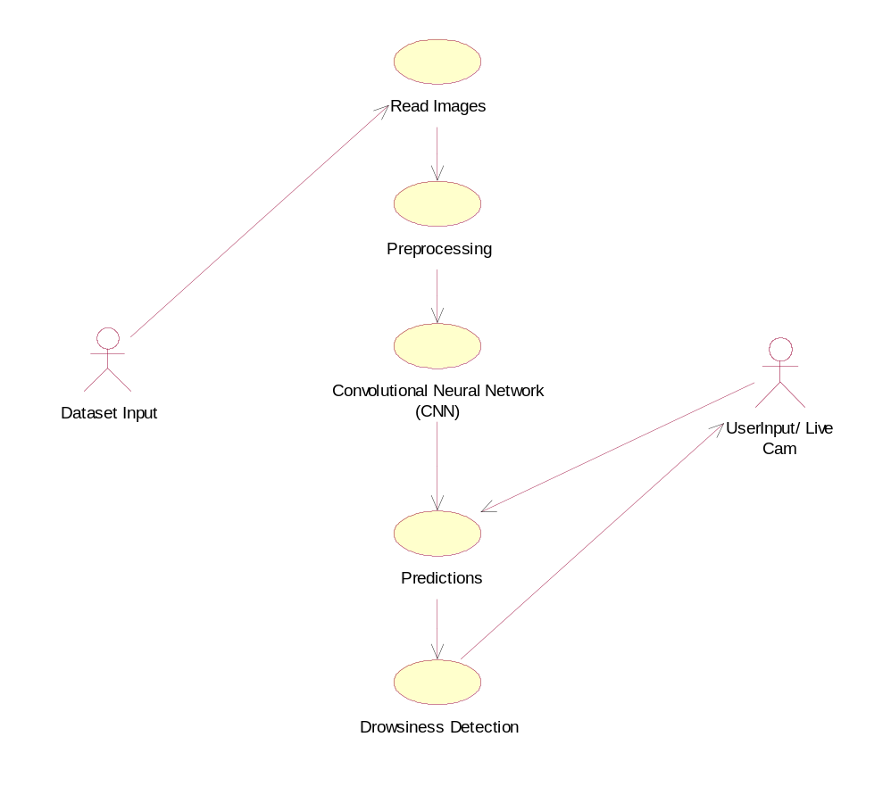

EXPLANATION:
The main purpose of a use case diagram is to show what system functions are performed for which actor. Roles of the actors in the system can be depicted. The above diagram consists of user as actor. Each will play a certain role to achieve the concept.
4.2.2 CLASS DIAGRAM
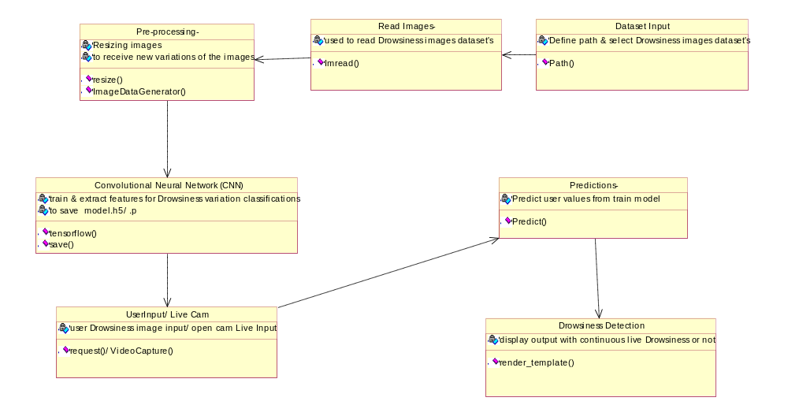

EXPLANATION
In this class diagram represents how the classes with attributes and methods are linked together to perform the verification with security. From the above diagram shown the various classes involved in our project.

4.2.3 OBJECT DIAGRAM
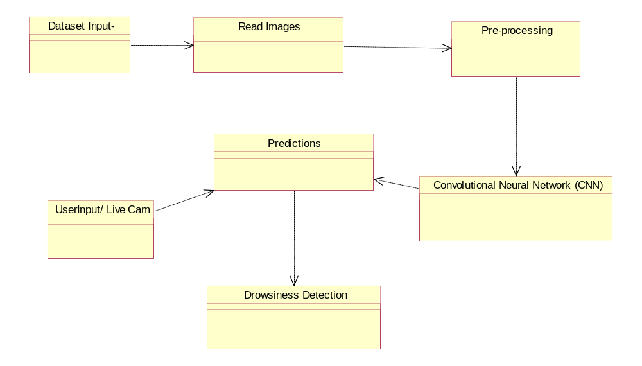

EXPLANATION:
In the above digram tells about the flow of objects between the classes. It is a diagram that shows a complete or partial view of the structure of a modeled system. In this object diagram represents how the classes with attributes and methods are linked together to perform the verification with security.

4.2.4 STATE DIAGRAM
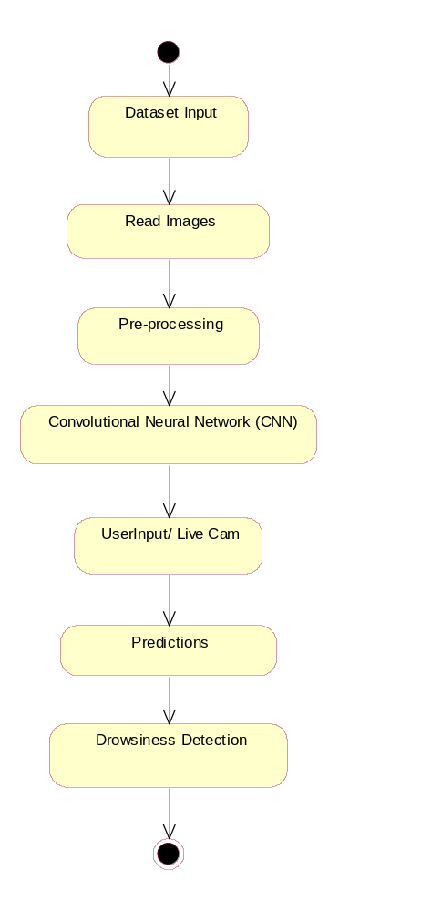

EXPLANATION:
State diagram are a loosely defined diagram to show workflows of stepwise activities and actions, with support for choice, iteration and concurrency. State diagrams require that the system described is composed of a finite number of states; sometimes, this is indeed the case, while at other times this is a reasonable abstraction. Many forms of state diagrams exist, which differ slightly and have different semantics.
4.2.5 ACTIVITY DIAGRAM
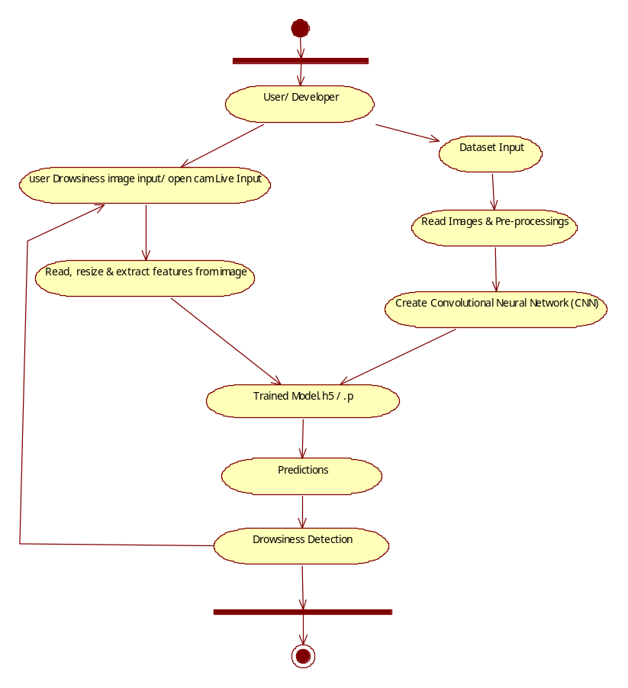

EXPLANATION:
Activity diagrams are graphical representations of workflows of stepwise activities and actions with support for choice, iteration and concurrency. In the Unified Modeling Language, activity diagrams can be used to describe the business and operational step-by-step workflows of components in a system. An activity diagram shows the overall flow of control.

4.2.6 SEQUENCE DIAGRAM
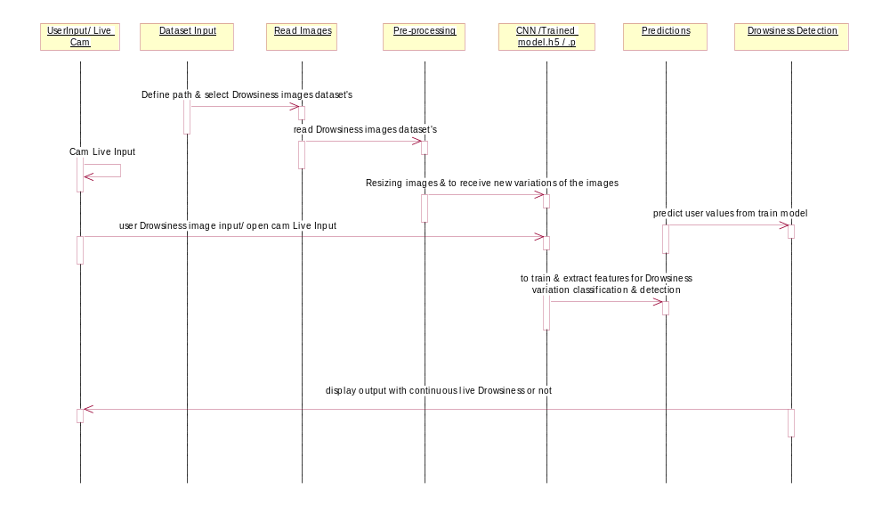
EXPLANATION:
A sequence diagram in Unified Modeling Language (UML) is a kind of interaction diagram that shows how processes operate with one another and in what order. It is a construct of a Message Sequence Chart. A sequence diagram shows object interactions arranged in time sequence. It depicts the objects and classes involved in the scenario and the sequence of messages exchanged between the objects needed to carry out the functionality of the scenario.

4.2.7 COLLABORATION DIAGRAM

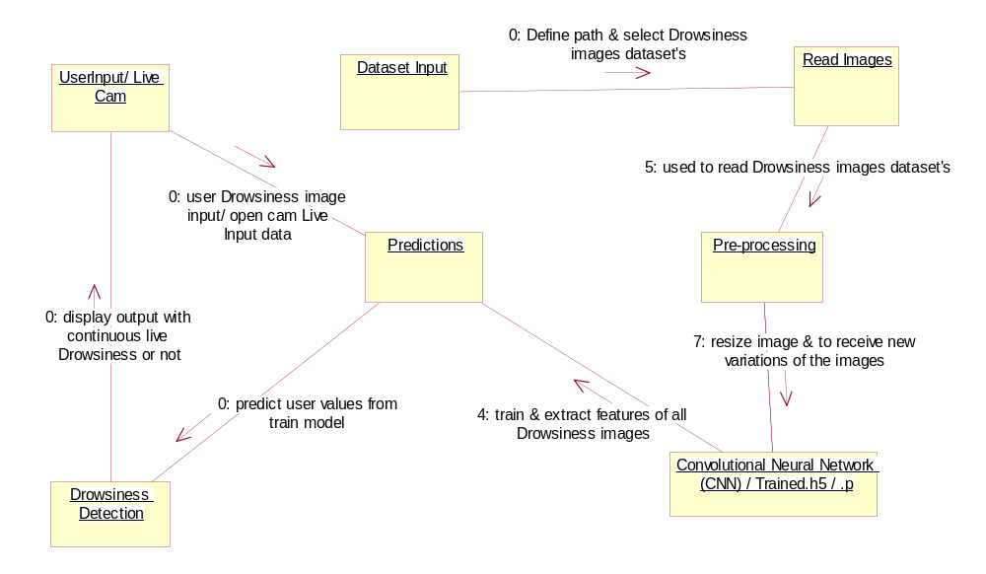

EXPLANATION:
A collaboration diagram, also called a communication diagram or interaction diagram, is an illustration of the relationships and interactions among software objects in the Unified Modeling Language (UML). The concept is more than a decade old although it has been refined as modeling paradigms have evolved.

4.2.8 COMPONENT DIAGRAM
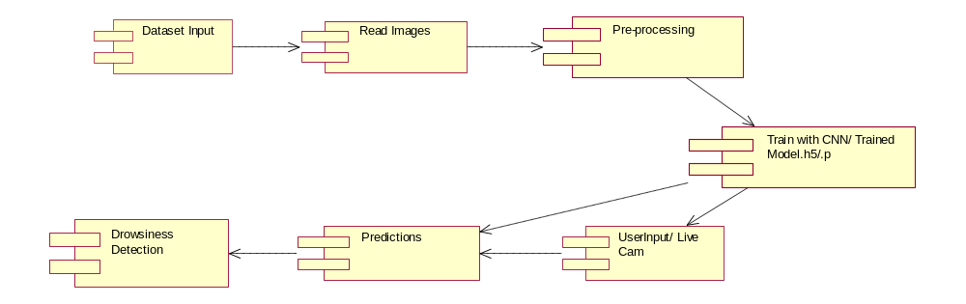

EXPLANATION

In the Unified Modeling Language, a component diagram depicts how components are wired together to form larger components and or software systems. They are used to illustrate the structure of arbitrarily complex systems. User gives main query and it converted into sub queries and sends through data dissemination to data aggregators. Results are to be showed to user by data aggregators. All boxes are components and arrow indicates dependencies.

4.2.9 Data Flow Diagram
Level 0
Create CNN (Convolutional Neural Network), Train data & save like TrainedModel.h5/.p
Eye & Yawn images Data Input
User
Read Images & Pre-processing
Level 1
User Drowsiness image input/ open cam Live Input
Load TrainedModel.h5/ .p & apply converted data
Drowsiness Detection

Read, Resize & Array conversion of images/ Frames

4.2.10 DEPLOYMENT DIAGRAM
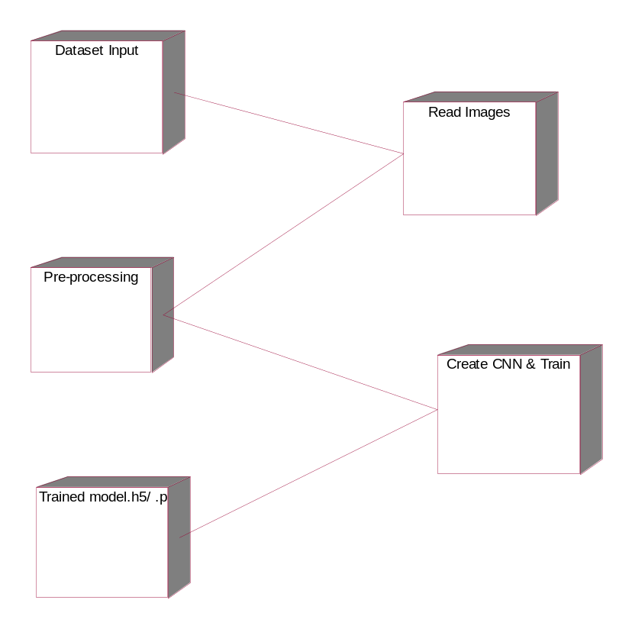

EXPLANATION:
Deployment Diagram is a type of diagram that specifies the physical hardware on which the software system will execute. It also determines how the software is deployed on the underlying hardware. It maps software pieces of a system to the device that are going to execute it.

-

SYSTEM ARCHITECTURE:

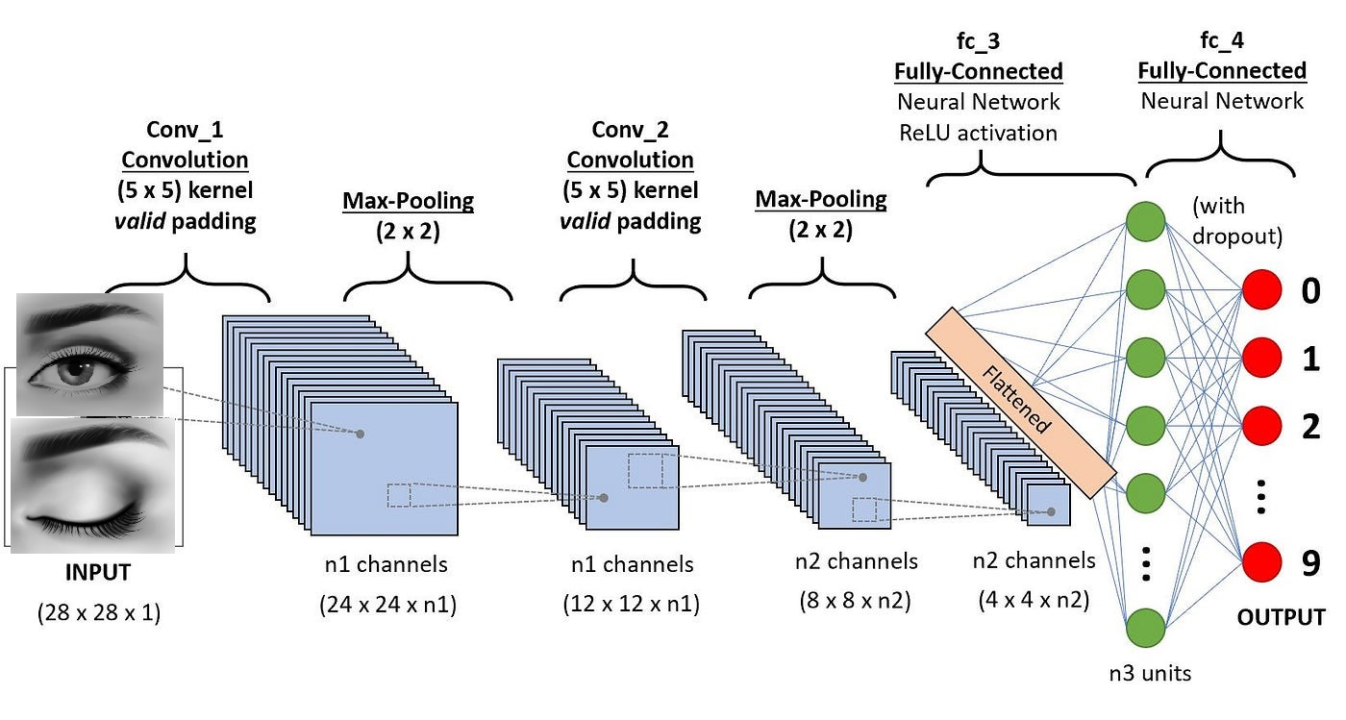

Fig 4.11: System Architecture

CHAPTER 5
DEVELOPMENT TOOLS
5.1 Python
Python is a high-level, interpreted, interactive and object-oriented scripting language. Python is designed to be highly readable. It uses English keywords frequently where as other languages use punctuation, and it has fewer syntactical constructions than other languages.

5.2 History of Python
Python was developed by Guido van Rossum in the late eighties and early nineties at the National Research Institute for Mathematics and Computer Science in the Netherlands.
Python is derived from many other languages, including ABC, Modula-3, C, C++, Algol-68, SmallTalk, and Unix shell and other scripting languages.
Python is copyrighted. Like Perl, Python source code is now available under the GNU General Public License (GPL).
Python is now maintained by a core development team at the institute, although Guido van Rossum still holds a vital role in directing its progress.

5.3 Importance of Python
- Python is Interpreted − Python is processed at runtime by the interpreter. You do not need to compile your program before executing it. This is similar to PERL and PHP.
- Python is Interactive − You can actually sit at a Python prompt and interact with the interpreter directly to write your programs.
- Python is Object-Oriented − Python supports Object-Oriented style or technique of programming that encapsulates code within objects.
- Python is a Beginner's Language − Python is a great language for the beginner-level programmers and supports the development of a wide range of applications from simple text processing to WWW browsers to games.

5.4 Features of Python
- Easy-to-learn − Python has few keywords, simple structure, and a clearly defined syntax. This allows the student to pick up the language quickly.
- Easy-to-read − Python code is more clearly defined and visible to the eyes.
- Easy-to-maintain − Python's source code is fairly easy-to-maintain.
- A broad standard library − Python's bulk of the library is very portable and cross-platform compatible on UNIX, Windows, and Macintosh.
- Interactive Mode − Python has support for an interactive mode which allows interactive testing and debugging of snippets of code.
- Portable − Python can run on a wide variety of hardware platforms and has the same interface on all platforms.
- Extendable − You can add low-level modules to the Python interpreter. These modules enable programmers to add to or customize their tools to be more efficient.
- Databases − Python provides interfaces to all major commercial databases.
- GUI Programming − Python supports GUI applications that can be created and ported to many system calls, libraries and windows systems, such as Windows MFC, Macintosh, and the X Window system of Unix.
- Scalable − Python provides a better structure and support for large programs than shell scripting.

Apart from the above-mentioned features, Python has a big list of good features, few are listed below −
- It supports functional and structured programming methods as well as OOP.
- It can be used as a scripting language or can be compiled to byte-code for building large applications.
- It provides very high-level dynamic data types and supports dynamic type checking.
- IT supports automatic garbage collection.
- It can be easily integrated with C, C++, COM, ActiveX, CORBA, and Java.
5.5 Libraries used in python
- numpy - mainly useful for its N-dimensional array objects.
- pandas - Python data analysis library, including structures such as dataframes.
- matplotlib - 2D plotting library producing publication quality figures.
- scikit-learn - the machine learning algorithms used for data analysis and data mining tasks.
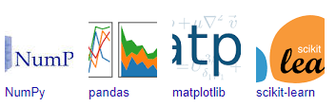
Figure : NumPy, Pandas, Matplotlib, Scikit-learn

CHAPTER 6
IMPLEMENTATION
6.1 GENERAL
Coding:

CHAPTER 7
SNAPSHOTS
General:
This project is implements like application using python and the Server process is maintained using the SOCKET & SERVERSOCKET and the Design part is played by Cascading Style Sheet.

SNAPSHOTS

CHAPTER 8
SOFTWARE TESTING

8.1 GENERAL
The purpose of testing is to discover errors. Testing is the process of trying to discover every conceivable fault or weakness in a work product. It provides a way to check the functionality of components, sub assemblies, assemblies and/or a finished product It is the process of exercising software with the intent of ensuring that the Software system meets its requirements and user expectations and does not fail in an unacceptable manner. There are various types of test. Each test type addresses a specific testing requirement.

8.2 DEVELOPING METHODOLOGIES
The test process is initiated by developing a comprehensive plan to test the general functionality and special features on a variety of platform combinations. Strict quality control procedures are used. The process verifies that the application meets the requirements specified in the system requirements document and is bug free. The following are the considerations used to develop the framework from developing the testing methodologies.

8.3Types of Tests

8.3.1 Unit testing
Unit testing involves the design of test cases that validate that the internal program logic is functioning properly, and that program input produce valid outputs. All decision branches and internal code flow should be validated. It is the testing of individual software units of the application .it is done after the completion of an individual unit before integration. This is a structural testing, that relies on knowledge of its construction and is invasive. Unit tests perform basic tests at component level and test a specific business process, application, and/or system configuration. Unit tests ensure that each unique path of a business process performs accurately to the documented specifications and contains clearly defined inputs and expected results.

8.3.2 Functional test
Functional tests provide systematic demonstrations that functions tested are available as specified by the business and technical requirements, system documentation, and user manuals.
Functional testing is centered on the following items:
Valid Input : identified classes of valid input must be accepted.
Invalid Input : identified classes of invalid input must be rejected.
Functions : identified functions must be exercised.
Output : identified classes of application outputs must be exercised.
Systems/Procedures: interfacing systems or procedures must be invoked.

8.3.3 System Test
System testing ensures that the entire integrated software system meets requirements. It tests a configuration to ensure known and predictable results. An example of system testing is the configuration oriented system integration test. System testing is based on process descriptions and flows, emphasizing pre-driven process links and integration points.

8.3.4 Performance Test
The Performance test ensures that the output be produced within the time limits,and the time taken by the system for compiling, giving response to the users and request being send to the system for to retrieve the results.

8.3.5 Integration Testing
Software integration testing is the incremental integration testing of two or more integrated software components on a single platform to produce failures caused by interface defects.
The task of the integration test is to check that components or software applications, e.g. components in a software system or – one step up – software applications at the company level – interact without error.

8.3.6 Acceptance Testing
User Acceptance Testing is a critical phase of any project and requires significant participation by the end user. It also ensures that the system meets the functional requirements.

Acceptance testing for Data Synchronization:
- The Acknowledgements will be received by the Sender Node after the Packets are received by the Destination Node
- The Route add operation is done only when there is a Route request in need
- The Status of Nodes information is done automatically in the Cache Updation process

8.2.7 Build the test plan

Any project can be divided into units that can be further performed for detailed processing. Then a testing strategy for each of this unit is carried out. Unit testing helps to identity the possible bugs in the individual component, so the component that has bugs can be identified and can be rectified from errors.

CHAPTER 9
FUTURE ENHANCEMENT

9.1 FUTURE ENHANCEMENTS:
In future scope, In order to improve the accuracy and dependability of driver sleepiness detection, our research plans to incorporate other metrics, such as heart rate and sensor body measurements. With this addition, the driver's physiological condition will be better understood, making the system even more resilient and adaptable. Our framework's ongoing development has the ability to establish new benchmarks for preventive traffic safety measures.

CHAPTER 10
CONCLUSIONAND REFERENCES

10.1 CONCLUSION
In conclusion, our proposed Driver Drowsiness Detection system is a ground-breaking approach that demonstrates exceptional precision in recognising and reducing the dangers related to driving while fatigued. Our solution strategically overcomes the drawbacks of centralised approaches when it is deployed on a distributed edge architecture, guaranteeing efficient administration within the defined region of interest. We attain an exceptional accuracy of 97.7% by using a two-step detection mechanism: facial expression analysis through CNN models for eyes and mouth classifiers. Additionally, our method improves the user experience overall and maintains user privacy by integrating manual UI input via Flask. This all-encompassing strategy, which combines local and global detections, creates a strong basis for real-time sleepiness detection and ultimately improves road safety.

10.2 REFERENCES
[1] Fatigued Driver National Safety Council. Accessed: Nov. 2022. [Online]. Available: https://www.nsc.org/road/safety-topics/fatigued-driver
(2010).
[2] The Prevalence and Impact of Drowsy Driving. [Online]. Available: https://aaafoundation.org/prevalence-impact-drowsy-driving/ .
[3] M. K. Hussein, T. M. Salman, A. H. Miry, and M. A. Subhi, ‘‘Driver drowsiness detection techniques: A survey,’’ in Proc. 1st Babylon Int. Conf. Inf. Technol. Sci. (BICITS), Apr. 2021, pp. 45–51.
[4] S. Lawoyin, D.-Y. Fei, and O. Bai, ‘‘Accelerometer-based steering-wheel movement monitoring for drowsy-driving detection,’’ Proc. Inst. Mech. Eng., D, J. Automobile Eng., vol. 229, no. 2, pp. 163–173, 2015.
[5] H. Iwamoto, K. Hori, K. Fujiwara, and M. Kano, ‘‘Real-driving-implementable drowsy driving detection method using heart rate variability based on long short-term memory and autoencoder,’’ IFAC-PapersOnLine, vol. 54, no. 15, pp. 526–531, 2021.
[6] S. Khare, S. Palakkal, T. V. Hari Krishnan, C. Seo, Y. Kim, S. Yun, and S. Parameswaran, ‘‘Real-time driver drowsiness detection using deep learning and heterogeneous computing on embedded system,’’ in Computer Vision and Image Processing (Communications in Computer and Information Science), N. Nain, S. K. Vipparthi, and B. Raman, Eds. Cham, Switzerland: Springer, 2020, pp. 86–97.
[7] S. Park, F. Pan, S. Kang, and D. C. Yoo, ‘‘Driver drowsiness detection system based on feature representation learning using various deep networks,’’ in Proc. Asian Conf. Comput. Vis. in Lecture Notes in Computer Science, C.-S. Chen, J. Lu, and K.-K. Ma, Eds. Cham, Switzerland: Springer, 2017, pp. 154–164.
[8] B. Mandal, L. Li, G. S. Wang, and J. Lin, ‘‘Towards detection of bus driver fatigue based on robust visual analysis of eye state,’’ IEEE Trans. Intell. Transp. Syst., vol. 18, no. 3, pp. 545–557, Mar. 2017.
[9] J. Lyu, Z. Yuan, and D. Chen, ‘‘Long-term multi-granularity deep framework for driver drowsiness detection,’’ CoRR, vol. abs/1801.02325, 2018.
[10] M. Hashemi, B. Farahani, and F. Firouzi, ‘‘Towards safer roads: A deep learning-based multimodal fatigue monitoring system,’’ in Proc. Int. Conf. Omni-Layer Intell. Syst. (COINS), Aug. 2020, pp. 1–8.
[11] H. Lamaazi, R. Mizouni, S. Singh, and H. Otrok, ‘‘A mobile edge-based CrowdSensing framework for heterogeneous IoT,’’ IEEE Access, vol. 8, pp. 207524–207536, 2020.
[12] H. Lamaazi, R. Mizouni, H. Otrok, S. Singh, and E. Damiani, ‘‘Smart-3DM: Data-driven decision making using smart edge computing in hetero-crowdsensing environment,’’ Future Gener. Comput. Syst., vol. 131, pp. 151–165, Jun. 2022.
[13] J. W. Baek, B.-G. Han, K.-J. Kim, Y.-S. Chung, and S.-I. Lee, ‘‘Real-time drowsiness detection algorithm for driver state monitoring systems,’’ in Proc. 10th Int. Conf. Ubiquitous Future Netw. (ICUFN), Jul. 2018, pp. 73–75.
[14] B. Reddy, Y.-H. Kim, S. Yun, C. Seo, and J. Jang, ‘‘Real-time driver drowsiness detection for embedded system using model compression of deep neural networks,’’ in Proc. IEEE Conf. Comput. Vis. Pattern Recognit. Workshops (CVPRW), Jul. 2017, pp. 438–445.
[15] S. Abtahi, M. Omidyeganeh, S. Shirmohammadi, and B. Hariri, ‘‘YawDD: A yawning detection dataset,’’ in Proc. 5th ACM Multimedia Syst. Conf., Mar. 2014, pp. 24–28.
[16] C.-H. Weng, Y.-H. Lai, and S.-H. Lai, ‘‘Driver drowsiness detection via a hierarchical temporal deep belief network,’’ in Proc. Asian Conf. Comput. Vis. in Lecture Notes in Computer Science, C.-S. Chen, J. Lu, and K.-K. Ma, Eds. Cham, Switzerland: Springer, 2017, pp. 117–133.
[17] Q. Massoz, T. Langohr, C. Francois, and J. G. Verly, ‘‘The ULg multimodality drowsiness database (called DROZY) and examples of use,’’ in Proc. IEEE Winter Conf. Appl. Comput. Vis. (WACV), Mar. 2016, pp. 1–7.
[18] R. Ghoddoosian, M. Galib, and V. Athitsos, ‘‘A realistic dataset and baseline temporal model for early drowsiness detection,’’ in Proc. IEEE/CVF Conf. Comput. Vis. Pattern Recognit. Workshops (CVPRW), Jun. 2019, pp. 178–187.
[19] M. R. Carlos, L. C. González, J. Wahlström, G. Ramírez, F. Martínez, and G. Runger, ‘‘How smartphone accelerometers reveal aggressive driving behavior?—The key is the representation,’’ IEEE Trans. Intell. Transp. Syst., vol. 21, no. 8, pp. 3377–3387, Aug. 2020.
[20] G. Žylius, ‘‘Investigation of route-independent aggressive and safe driving features obtained from accelerometer signals,’’ IEEE Intell. Transp. Syst. Mag., vol. 9, no. 2, pp. 103–113, Apr. 2017.
[21] J. Ferreira, E. Carvalho, B. V. Ferreira, C. de Souza, Y. Suhara, A. Pentland, and G. Pessin, ‘‘Driver behavior profiling: An investigation with different smartphone sensors and machine learning,’’ PLoS ONE, vol. 12, no. 4, Apr. 2017, Art. no. e0174959.
[22] M. Fazeen, B. Gozick, R. Dantu, M. Bhukhiya, and M. C. González, ‘‘Safe driving using mobile phones,’’ IEEE Trans. Intell. Transp. Syst., vol. 13, no. 3, pp. 1462–1468, Sep. 2012.
[23] L. Eboli, G. Mazzulla, and G. Pungillo, ‘‘How to define the accident risk level of car drivers by combining objective and subjective measures of driving style,’’ Transp. Res. Part F, Traffic Psychol. Behav., vol. 49, pp. 29–38, Aug. 2017.

